Maryam Ashraf, Sami Mahmoud, and Bryce Manley
Dr. Mubarek Mohammed
CISS 247
Date: 12/10/2025
Final Project: Hardening CrackMe Binaries Against Reverse Engineering

Final Project Report
Introduction
In this lab, we expanded on the reverse engineering work from Lab 6 by taking the original CrackMe binaries and hardening them to make reverse analysis significantly more difficult. The first version of each CrackMe was extremely easy to break using basic tools such as gdb, Ghidra, and even the strings command. Our goal this time was to take the perspective of a defender: identifying weaknesses in the original binaries, rewriting parts of their logic, and applying real-world protective techniques such as compiler-based hardening, logic obfuscation, anti-debugging, and runtime encoding. The main objective was not only to reinforce what we learned about reverse engineering but also to experience how software can intentionally resist that analysis. As part of our final submission, we also attempted automated cracking methods, as our professor recommended, in order to evaluate how well our hardened versions held up against scripting and symbolic tools.
Lab Setup
We completed the project in an Ubuntu Linux environment and used several analysis and debugging tools throughout the development. The main tools included gcc for compilation, Ghidra for static reverse engineering, gdb for dynamic debugging, and utilities such as strings, hexdump, and objdump for deeper inspection. We also used Python for brute-force automation testing and experimented briefly with angr for symbolic execution. Each team member kept their CrackMe’s baseline and hardened versions organized in separate folders, which helped us track changes, test before-and-after behavior, and document results consistently.
Methodology
We followed a shared process that allowed us to stay consistent across the three CrackMe levels. We began by fully reverse engineering the original binaries, taking notes on how the password was checked, where sensitive values were stored, and how readable the program logic was in Ghidra. In every case, the password was visible as a constant, the control flow was extremely simple, and the success and failure messages appeared directly in plaintext inside the compiled binary. These weaknesses made reversing trivial and demonstrated exactly why real software must use stronger defenses.
After documenting the weaknesses, we rewrote and hardened each CrackMe in a different way. Bryce focused on CrackMe0x01 and turned it into an anti-debugging, self-modifying binary that exploited the “one debugger at a time” rule in Linux. The child process executed a deliberately invalid syscall when the correct password was entered. Under normal execution, the parent process intercepted the syscall via ptrace and rewrote it into a valid syscall. However, when gdb was attached, the parent was blocked from tracing, which meant the invalid syscall was never fixed and the program silently failed. This effectively prevented debugging the success path.
Sami hardened CrackMe0x02 by combining compiler-level protections with several layers of obfuscation. He used tools such as symbol stripping, PIE compilation, and stack protection, which removed readable function names, randomized memory layout, and inserted canaries. He also modified the program logic by adding misleading branches, fake checks, and unnecessary computation designed to confuse both debuggers and decompilers. These changes did not make the program impossible to reverse, but they did raise the complexity and removed the straightforward mathematical relationship between the input password and the stored constant.
Maryam rewrote CrackMe0x03 with a strong focus on protecting strings and hiding the real password. All user-facing messages were XOR-encoded so they would not appear in plaintext in the compiled binary. The messages were only revealed through a runtime decode function, which meant Ghidra no longer displayed them clearly. She also replaced the original direct password comparison with a transform function that used XOR and arithmetic operations to obscure the true password value. Adding the volatile keyword prevented the compiler from optimizing away the decoding operations, and leaving unused “noise” functions in the code added even more confusion to Ghidra’s output.
Once the code modifications were complete, we recompiled the binaries using hardening flags such as -fstack-protector-all, -fPIE -pie, and linker options for RELRO and immediate binding. After compiling, we applied strip where appropriate. These steps collectively removed symbolic information, altered memory placement, and added runtime integrity checks. We then attempted to reverse each hardened binary again to evaluate how much more difficult analysis had become.
Results and Discussion
Testing the hardened binaries revealed that each CrackMe responded differently to both manual and automated analysis. Bryce’s CrackMe0x01 demonstrated strong resistance to dynamic debugging. When run normally, entering the correct password produced the expected output, but under gdb the program could not return the success message because the parent is not able to fix the invalid syscall (syscall 1000). This verified that the anti-debugging and self-modifying code was working as intended. It also showed the trade-off between performance and protection, since there was a measured 60%+ performance cost of this implementation when compared against the original.
Sami’s CrackMe0x02 became significantly noisier inside Ghidra. Because function names were stripped and the binary became position-independent, debugging required more effort and guesswork. The added decoys and misleading math introduced a level of uncertainty during analysis, forcing a reverser to follow multiple code paths before finding the real logic. Although it was still possible to reverse with enough time, the difficulty increased from trivial to meaningfully challenging.
Maryam’s CrackMe0x03 produced some of the clearest improvements in static protection. Running strings on the binary no longer revealed the success or failure messages, and Ghidra displayed only the XOR decoding loop rather than readable text. The transform function successfully hid the real password behind a sequence of operations, making it much harder to identify at a glance. The leftover noise functions also contributed to a cluttered decompiled output, slowing down analysis for anyone unfamiliar with the codebase.
Automated Cracking Attempts
Based on our professor’s feedback, we attempted to crack all three hardened binaries using automation rather than manual analysis. Our first approach was to write a brute-force script in bash that took in two numbers as a target range and iterated through ranges of possible numeric password combinations and observed the programs’ output or exit behavior. This method worked quickly against Bryce’s and Sami’s CrackMe because both keys were short as they were four numbers long each:
Sami’s Crackme (4.725s)
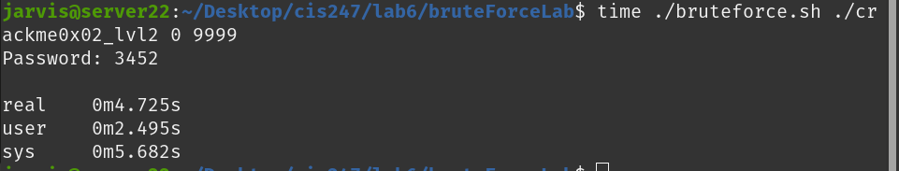
Bryce’s Crackme (4.081 seconds):
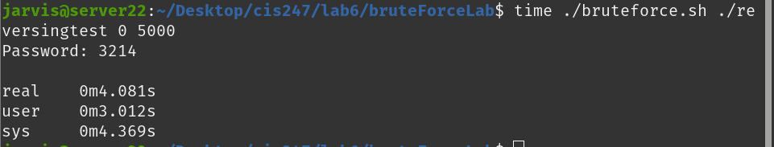
Because Maryam’s crackme uses a longer password (6 digits long) it takes significantly longer to crack. This demonstrated how password length (even two digits longer) directly impacts resistance to brute-force attacks:
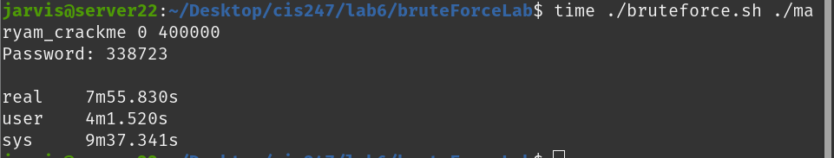
These results show that no matter how much obfuscation you add, a short numeric password is still vulnerable to automated guessing. One way that real systems defend against this is by using Key Derivation Functions (KDFs). Because our Crackme’s did not have any brute force protection we were able to very quickly iterate through all the numbers in a given range and quickly find the password. Standard encryption algorithms like AES incorporate brute force protection by incorporating Key Derivation Function (KDF). This takes a short user generated password like MyDog123 and transforms it into a longer key like 2b7e151628aed2a6abf7158809cf4f3c. As demonstrated by our brute force attack, longer keys lead to vastly longer crack times so this is an effective defence against this type of bruit force attack.
Passwords get converted to keys via a Key Derivation Function (KDF):
Password → KDF → AES Key
"MyDog123" → PBKDF2 → 2b7e151628aed2a6abf7158809cf4f3c

Conclusion
This project gave us hands-on experience with both breaking and defending software. We learned how simple logic, visible constants, and readable strings make binaries extremely vulnerable to reverse engineering. By rewriting and hardening the CrackMe’s, we also saw how different techniques add layers of confusion that work together to slow down or block analysis. Throughout the process, we encountered several challenges, including compiler optimizations interfering with obfuscation, ensuring that decoy logic did not break program execution, and debugging self-modifying code that behaved differently under various conditions.
The automated cracking portion of the project demonstrated that while human analysis remains powerful, defensive techniques can significantly reduce the effectiveness of brute-force scripts and symbolic execution tools. Overall, this lab improved our understanding of program analysis, secure compilation, anti-debugging strategies, and how attackers adapt to defensive measures. If we were to continue expanding this project, we would explore more advanced obfuscation techniques such as opaque predicates, instruction substitution, or even small custom virtual machines to further resist both manual and automated analysis.

References
LinuxSecurity. (n.d.). Hacker’s Corner: Complete guide to anti-debugging in Linux (Part 2). Retrieved from
https://linuxsecurity.com/features/hacker-s-corner-complete-guide-to-anti-debugging-in-linux-part-2
CodeBreakers. (2006). Anti-Debugging Techniques. Retrieved from
https://repo.zenk-security.com/Reversing%20.%20cracking/CodeBreakers%202006%20-%20AntiDebugging%20techniques.pdf
ThreatDown. (n.d.). Nowhere to hide: Three methods of XOR obfuscation. Retrieved from
https://www.threatdown.com/blog/nowhere-to-hide-three-methods-of-xor-obfuscation/
Singh, P. (n.d.). Hiding code like a spy: VM-based code obfuscation in C with runtime decryption. Medium. Retrieved from
https://medium.com/@112piyushsingh/hiding-code-like-a-spy-vm-based-code-obfuscation-in-c-with-runtime-decryption-ccb24c53b7d6
GeeksforGeeks. (n.d.). Understanding the volatile qualifier in C. Retrieved from
https://www.geeksforgeeks.org/c/understanding-volatile-qualifier-in-c/
Unprotect.it. (n.d.). Opaque Predicate. Retrieved from
https://unprotect.it/technique/opaque-predicate/
StackOverflow. (n.d.). How to remove strings from a compiled binary? Retrieved from
https://stackoverflow.com/questions/2872638/how-to-remove-strings-from-a-compiled-binary-so

Project Documentation:

This section records every step taken to analyze, modify, and harden the CrackMe binary. It includes the baseline program behavior, the applied hardening techniques, and the resulting changes in reverse-engineering difficulty. Screenshots, code snippets, and explanations are provided to clearly show the before and after of each technique.

Sami - Crackme0x02:

Baseline (Initial Program Behavior):

Logic Summary:
- Prints a welcome or prompt message (puts + printf).
- Reads an integer input from the user (scanf).
- Multiplies the input by 0x159 (345 in decimal).
- Compares that product to the constant 0x122c1c (1,190,940 in decimal).
- If they match, prints the “Password OK : )” string.
- If not, prints the “Invalid Password!” string.
- Program ends by returning 0.

Ghidra View:
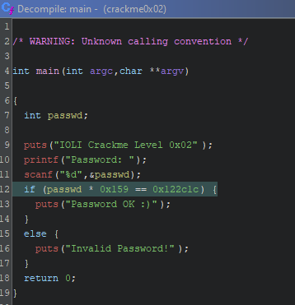

Assembly code via gdb:
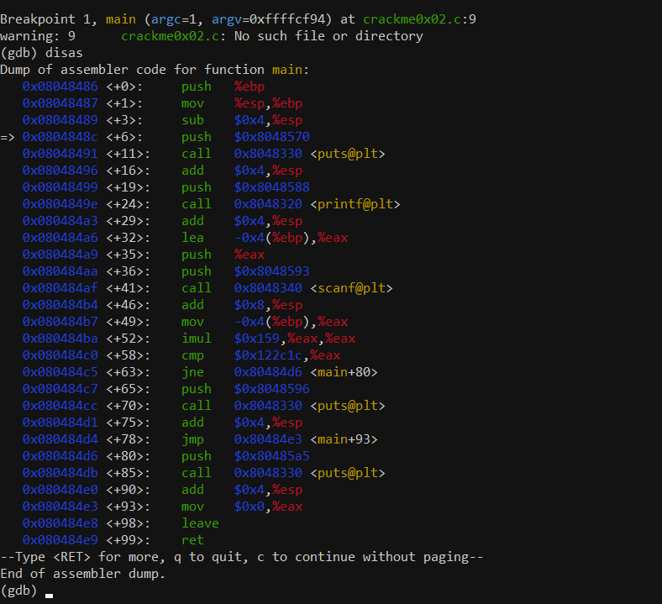

Example run in gdb:
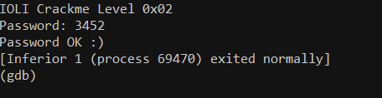

Derived Formula to crack password: x * 345 = 1190940, with x being the password. 1190940 / 345 = 3452. x = 3452

Why this is insecure:
- The multiplication constant 0x159 appears directly in the assembly.
- The comparison constant 0x122c1c also appears directly in the assembly.
- There’s no string obfuscation.
- No extra functions or noise in control flow.
- No anti-debugging.
- No compiler hardening flags.
- No decoy branches or distractions.

Level 1 - Compiler Level Hardening:

Technique Applied - Strip Symbols via strip command:

What this does:
- Removes symbol names (main, puts@plt, etc).
- Ghidra and gdb no longer show helpful labels like before
- Can no longer run b main through gdb, you must set breakpoints by address or function index:
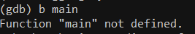
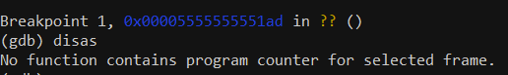

Technique Applied - Position Independent Executable (PIE):

What this does:
- Makes the program load at a random memory address each run, increasing protection by preventing attackers from relying on fixed code locations.

Reconstructed C code via CLion:
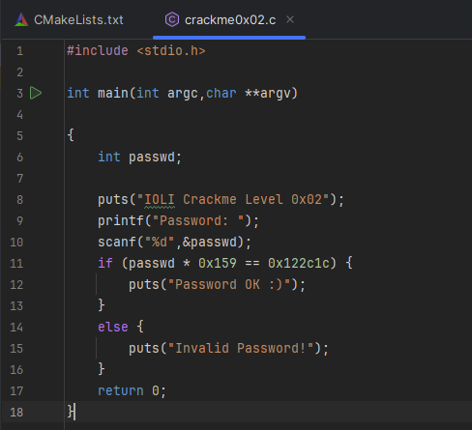

Applying PIE (gcc - fPie -pie crackme0x02.c -o crackme_pie):
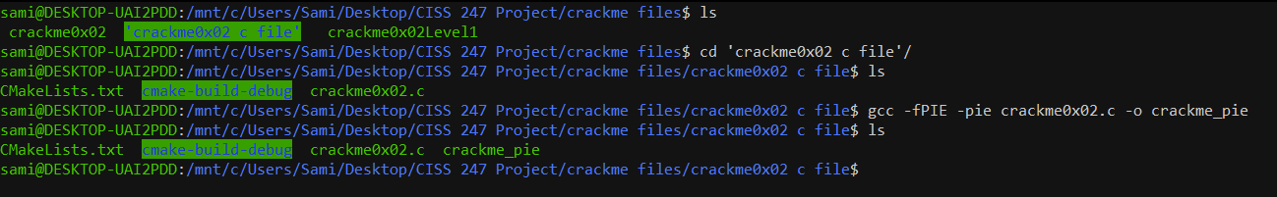

Technique Applied: Stack Protector:

What this does:
- Inserts stack canaries
- Adds extra assembly instructions and checks

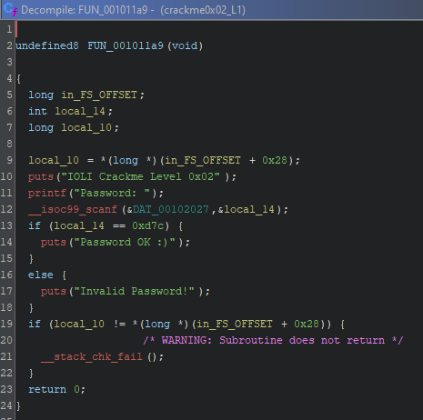

Level 1 Overall Difficulty Rating - Low/Medium:

These techniques do make debugging a little harder as it removes obvious function labels and adds extra garbage/noise. However an experienced debugger would still be able to break it easily.

Level 2 - Code-Level Obsfuscation:

Technique Applied - Adding useless decoy comparisons / Fake success branches:

What this does:
- This would potentially waste the time of a reverser as they would be following a meaningless branch.
- Terminating the program would also trick someone who isn’t careful while stepping through the program into thinking they found the correct password.
- Adding meaningless math logic would also confuse and waste the time of a reverser.
- You can also move the real password check to somewhere less obvious than the end of the program.

Decoy Comparison Example:
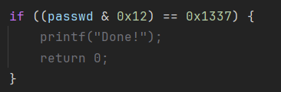

Misleading early check for password:
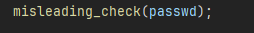

Adding extra unnecessary password logic:
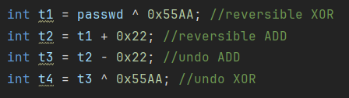
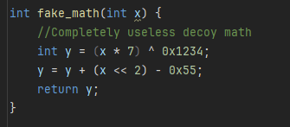

Using (void)junk to prevent compiler from warning and removing extra noise:
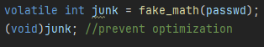

Level 2 Overall Difficulty - Medium:

At this stage, you would have to have knowledge of dataflow, reconstruction, math tracing, and an understanding of decoys to reverse the program. Unlike the last level, reversing the password would no longer be just spotting and multiplying the constant.

Maryam – Crackme0x03

Baseline Initial Program Behavior original crackme
Logic Summary
Original CrackMe 0x03 basically did this
- Prints a banner
puts("IOLI Crackme Level 0x03")
- Prompts for a password
printf("Password ")
- Reads an integer from the user using scanf
- Compares the input directly to a hard coded constant 0x52b23
- Depending on the result it calls shift with one of two encoded strings
One decodes to “Password OK!!! :)” and the other to “Invalid Password”
- Program then exits
So logically it is just
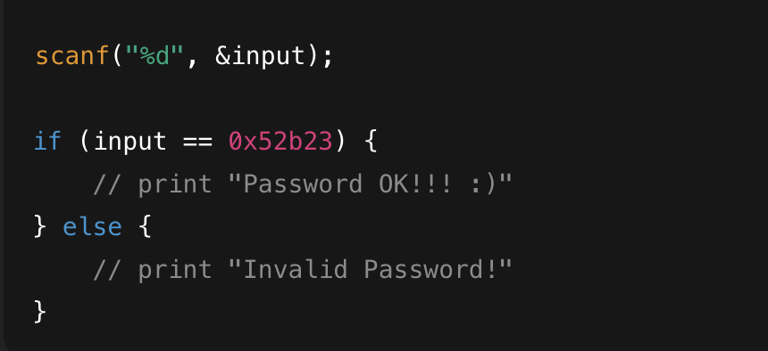
Ghidra View baseline
In Ghidra the original version is very friendly
- The string window shows the banner and the encoded strings that become the OK and FAIL messages
- The decompiled main shows a direct if (passwd == 0x52b23) check
- You can literally look at the constant 0x52b23 and know that is the password
So the reverser just does
- Open in Ghidra
- Look at main or test
- See 0x52b23
- Done
Why this is insecure
- The password value 0x52b23 is stored directly as a constant in the code
- The success and failure behavior is obvious from the messages and logic
- There is no string obfuscation
- No transformation or math to slow anyone down
- Basically any beginner with Ghidra can solve it just by reading

Level 1 String and Message Hardening my changes
Here I focused on hiding the obvious strings so you can not just run strings or look at the Ghidra string table and see the answer messages.
Technique Applied XOR encoding of status messages
Instead of storing these directly
- Password OK!!! :)
- Invalid Password!
I created two byte arrays where every character is stored as char ^ 0x37 and then decode them at runtime.
Example in my code
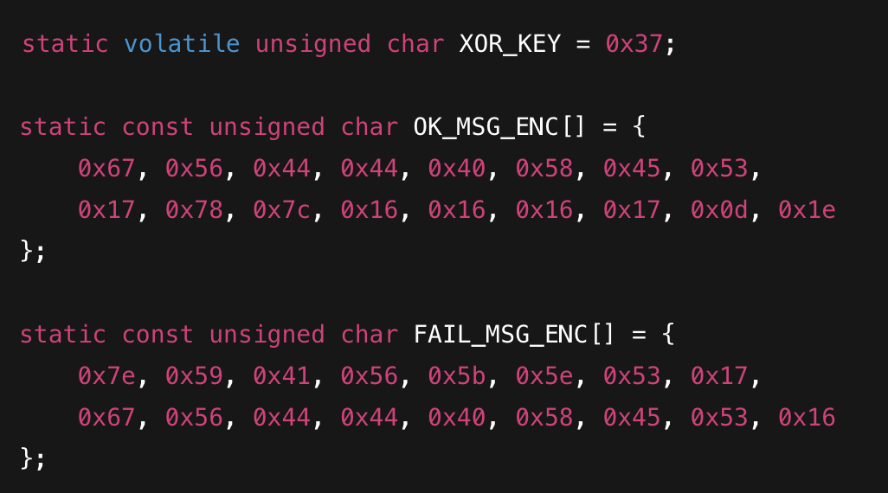
And the decoder
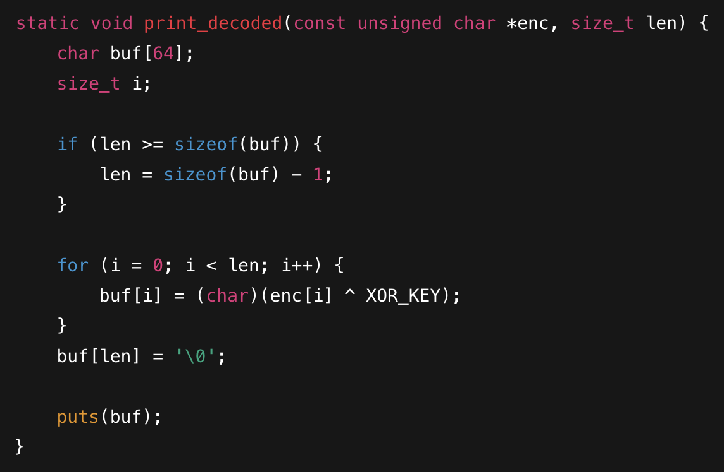
Then I just call
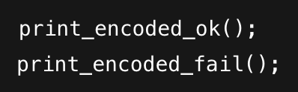
instead of printing the messages directly.
What this does
- The real strings never appear in the binary as plain text
- The only time “Password OK!!! :)” or “Invalid Password” exist is in RAM after decoding
- In Ghidra’s string view and in the strings command the messages do not show up anymore
- A reverser now has to find and understand the decode function to know what gets printed
Extra detail volatile key
I made the XOR key
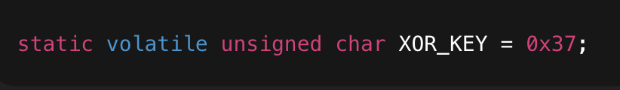
so the compiler can not just optimize everything and pre decode the string at compile time. The volatile keyword forces it to treat the key as a value only known at runtime.
Noise function kept from original
I also left the original shift function in the file
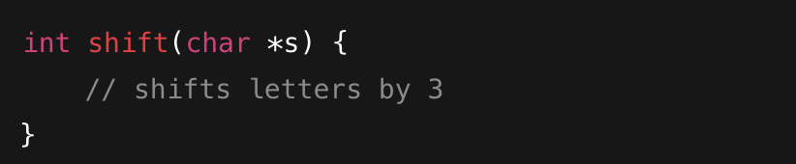
I do not use it in my logic but it is still there as extra noise. Someone looking at the decompile has to mentally filter this out.
Result in Ghidra for Level 1
- Strings window only shows the banner text and “Password ” and “Input error”
- The success and fail messages do not appear anywhere as clear strings
- There is a function that reads from some data region and XORs bytes with a key and prints them
- So from a string searching perspective the program is already much harder to understand

Level 2 Logic and Password Obfuscation my transform attempt
Next I tried to hide the numeric password so the constant 0x52b23 is not staring you in the face in Ghidra.
Technique Applied Transform based password check
Instead of
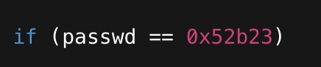
I wrote a transform function
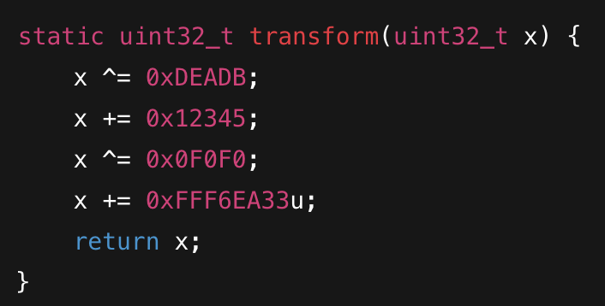
and then my test function does
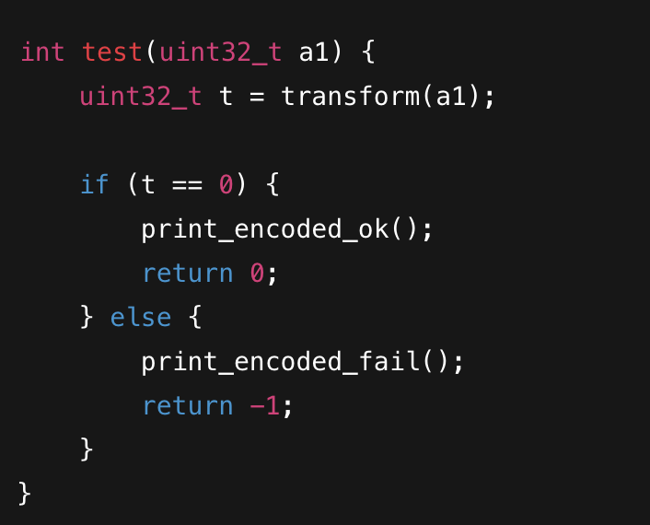
The idea is
- Only the real password will make transform(input) equal zero
- The actual password value is not written anywhere in the code
- Ghidra should just show some confusing math and a comparison to zero
- A reverser would have to reverse engineer the math instead of reading a constant
What this should do if everything cooperates
- No more direct 0x52b23 compare in the decompiled code
- The password is effectively hidden behind a chain of XOR and addition operations
- The only visible constants are weird values like 0xDEADB and 0xFFF6EA33 that do not look like passwords

Current Problem what I am still trying to fix
This is the part that is annoying
- My C code does not contain 0x52b23 anywhere except in a comment
- I compile the hardened file and strip it
- The messages are successfully hidden
- But in Ghidra I am still seeing a comparison against 0x52b23 in the decompiled view
So basically
- The string and message hardening is working
- The transform based password idea is written in code
- But either the compiler is optimizing it back into a direct compare or I am accidentally still opening an old binary
For now I am keeping this in my writeup as
- Implemented string obfuscation and runtime decode
- Implemented a math based transform to hide the password
- Currently debugging why the literal constant is still showing up in the decompile

Overall Difficulty Rating my honest take
Compared to the original
- You can not just run strings and instantly see the messages anymore
- You have to follow an XOR decode routine to figure out what gets printed
- The password logic is less obvious than a one line if (x == 0x52b23), especially once the transform is actually reflected in the final binary
I would call my final difficulty
- At least medium for someone new to reversing
- There are multiple layers
encoded messages
a decode function
a transform function
and leftover noise code
So I definitely made it more annoying to reverse than the original CrackMe 0x03.

Bryce - Crackme0x01

Techniques used: Self Modifying Code

Key Concept: In linux a process can only have one debugger referred to as a tracer.

Thus a program that debugs itself immediately upon launch ossupies the single debugger slot. If an external analyst uses a debugger like GDB it creates a conflict that breaks the program causing a crash.

Phase 1: Fork

The program begins by splitting into two processes the Parent (tracer) and the child(tracee):

int main(int argc, char **argv) {
pid_t child_pid = fork(); // The Split

if (child_pid == 0) {
tracee(); // Child
} else {
tracer(child_pid); //Parent
}
}
Phase 2:
Before the child runs the sensitive code (if password = 0xc8e), it first allows itself to be taced with the following code:
void tracee() {
// 1. Opt-in: Explicitly allow the parent to debug me
ptrace(PTRACE_TRACEME, 0, 0, 0);

// 2. Synchronization: Pause immediately!
raise(SIGCONT);

Once the parent allows the child to continue, then the child process runs the sensitive code (if (passwd == 0xc8e)). If the password is correct, then the child process executes an invalid system call (syscall 10000). Because syscall 10000 is invalid it will result in a crash unless the OS asks parent process to correct this.

If the parent process is attached—such as in a normal execution by running ./crackme01—the parent modifies the child’s CPU registers by changing syscall 10000 to syscall 1 to correct the invalid call and allow the child to run.

// ... inside the sensitive logic block ...

// 3. The Sensitive Check
if (passwd == 0xc8e) {
// 4. The Trap: Executing the invalid syscall
// This line will crash the program unless the Parent is there to fix it.
syscall(10000, str, 1, strlen(str));
}
}

Phase 3:
The parent process (tracer) waits for the child to pause as a result of the invalid syscall. The OS detects the error and pauses the child, and at this point the Parent process modifies the child’s CPU register to change the invalid syscall 10000 into syscall 1. This is where we get the self-modifying code aspect.

while(WIFSTOPPED(status)) {
struct user_regs_struct regs;
// Read the child's registers
ptrace(PTRACE_GETREGS, child_pid, 0, &regs);

// Check if the child is trying to run the fake syscall (10000)
if (regs.orig_rax == 10000) {

// 1. Change the syscall number to 1 (SYS_write)
regs.orig_rax = 1;

// 2. Swap the arguments (RDI and RSI were intentionally backwards)
unsigned long long int temp = regs.rdi;
regs.rdi = regs.rsi;
regs.rsi = temp;

// 3. Update the child's registers with the fix
ptrace(PTRACE_SETREGS, child_pid, 0, &regs);
}

ptrace(PTRACE_SYSCALL, child_pid, 0, 0); // Resume the child
waitpid(child_pid, &status, 0);
}
}

Verifying Protection in GDB

To verify the protection is working we can follow the child process in GDB. When analyzing in GDB a debugger is attached to the process, However, because the child process has already called ptrace(PTRACE_TRACEME) to allow the internal parent process to trace it, GDB’s attempt to attach blocks the internal parent from running and attaching.
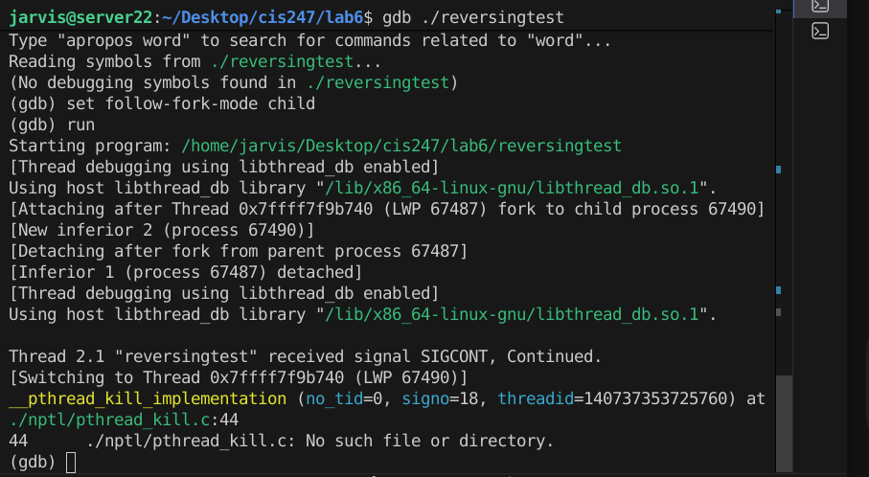

When we enter the correct password (3214) under GDB, the program enters the success branch and attempts to execute the 'trap' instruction (syscall 1000). In a normal execution, the internal parent process would detect this invalid call and repair it. However, because GDB is the active debugger, the internal parent is blocked. As a result, the kernel simply ignores the invalid system call, causing the print_secure function to fail silently. The program exits normally without printing the success message, proving that the protection successfully blocked the sensitive operation.

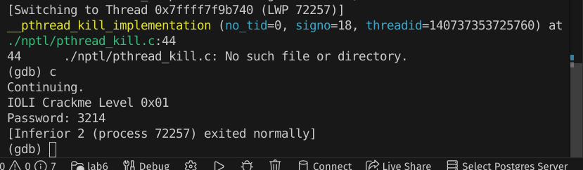

Defeating the Obfucvation.

Method 1 Ghidra:
The One-Debugger rule only applies to active running programs, not static analysis. This means that Ghidra is not at all impacted by this obfuscation and you can easily see the password: 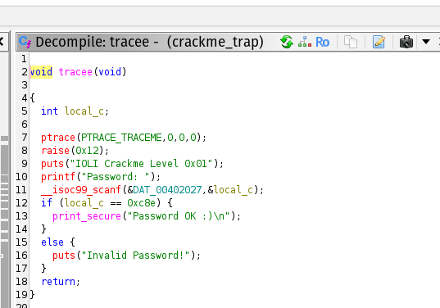

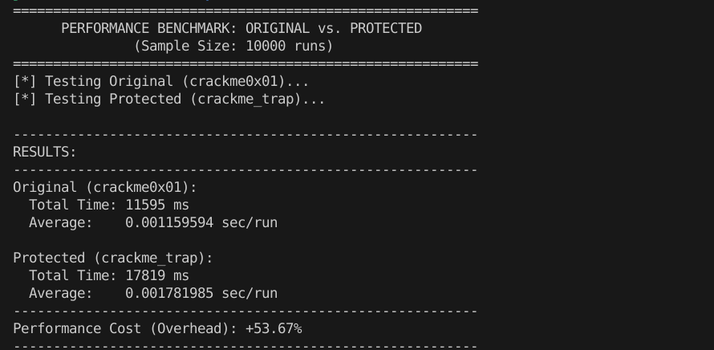

List of Obfuscation Techniques:

strip command (Sami):
- removes function/variable names that make reversing easier. example: strip crackme00.hardened
- https://www.ibm.com/docs/en/aix/7.1.0?topic=s-strip-command

Position Independent Executable (PIE) (Sami):
- https://www.redhat.com/en/blog/position-independent-executables-pie

Stack Protector (Sami):
- https://www.redhat.com/en/blog/security-technologies-stack-smashing-protection-stackguard
- https://security.stackexchange.com/questions/158609/how-is-the-stack-protection-enforced-in-a-binary

Self Modifying Code (Bryce)
- https://linuxsecurity.com/features/hacker-s-corner-complete-guide-to-anti-debugging-in-linux-part-2

Ptrace to stop debugging (Bryce)
- https://repo.zenk-security.com/Reversing%20.%20cracking/CodeBreakers%202006%20-%20AntiDebugging%20techniques.pdf

Obfuscating all messages using XOR encoding (Maryam)
- https://www.threatdown.com/blog/nowhere-to-hide-three-methods-of-xor-obfuscation/

Runtime String Decoding(Maryam)
- https://medium.com/@112piyushsingh/hiding-code-like-a-spy-vm-based-code-obfuscation-in-c-with-runtime-decryption-ccb24c53b7d6

Use of volatile to Prevent Compiler Optimization(Maryam)
- https://www.geeksforgeeks.org/c/understanding-volatile-qualifier-in-c/

Password Logic Obfuscation With Transform Function(Maryam)
- https://unprotect.it/technique/opaque-predicate/

Removal of Plaintext Password and Messages(Maryam)
- https://stackoverflow.com/questions/2872638/how-to-remove-strings-from-a-compiled-binary-so

